**Qn : How delete[] works ?**

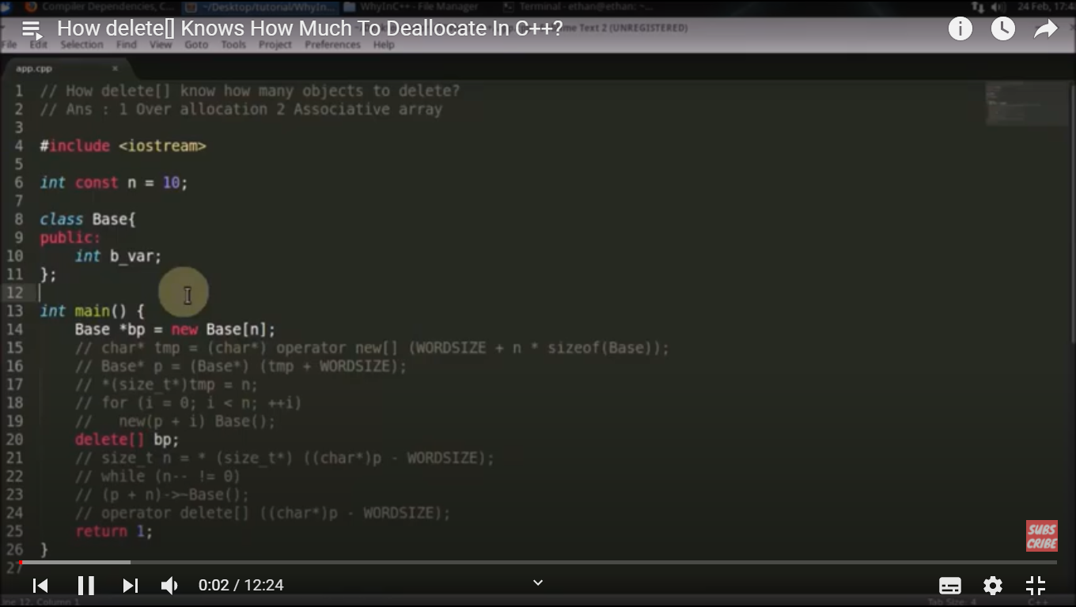

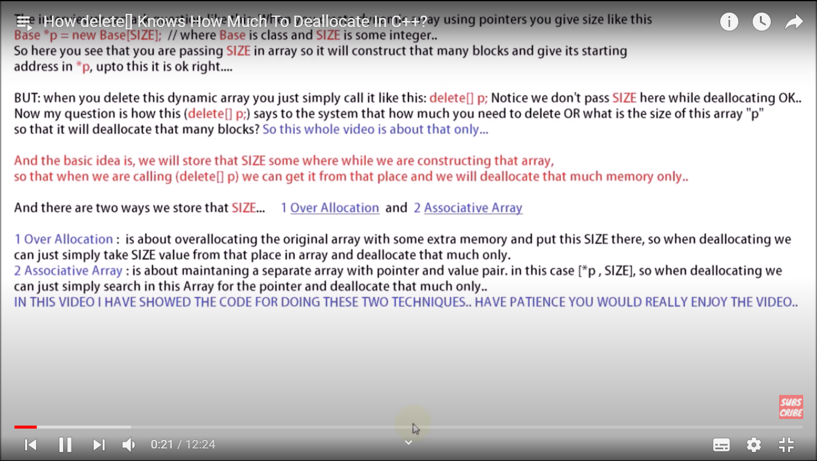

Qn : How compiler works in C/C++ ?

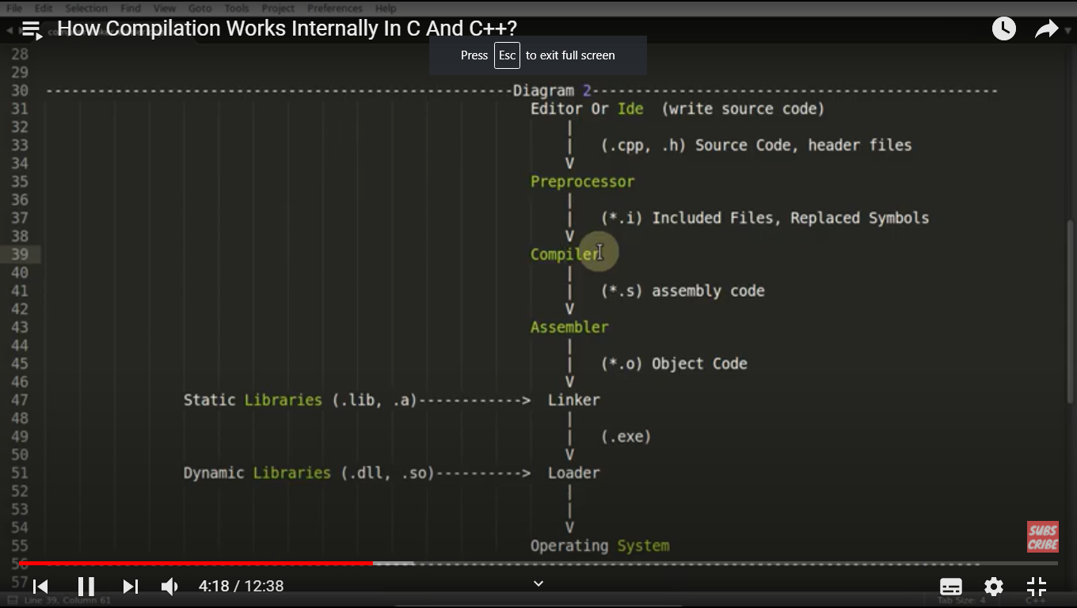

Command to generate .o, .i. .s and a.out files together :

g++ test.cpp --save-temps

Qn: What is difference between pointer and reference ?

1. Reassignment of reference is not possible.

int x = 20;

int &ref = x;

int y = 40;

ref = y; // ref is pointing to x so, x becomes 40 here

1. Reference should be initialized while creating, it can’t be initialized by NULL.

Qn : What is static_cast in C++ ?

Static_cast happens during compile time.

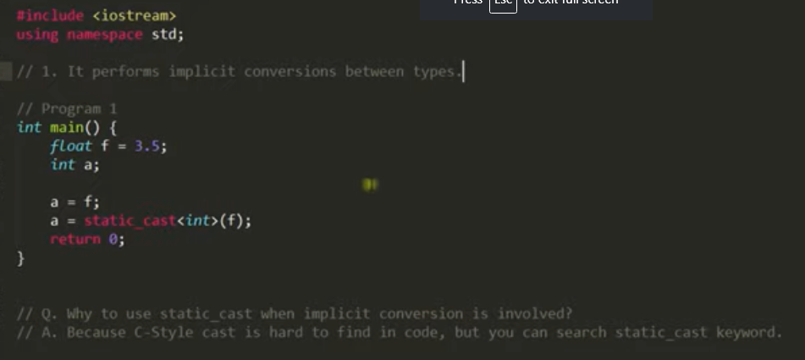

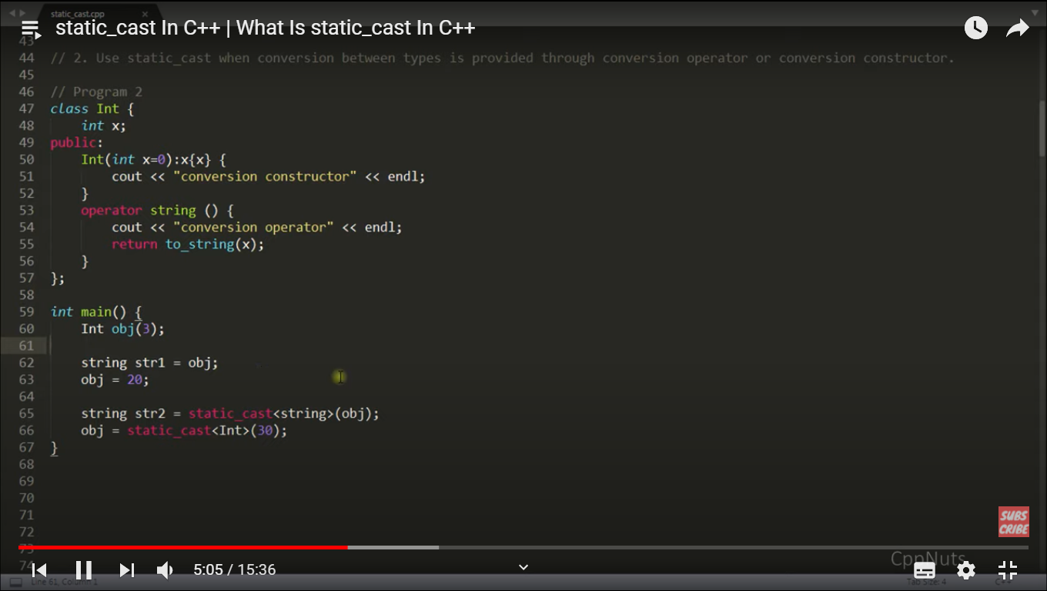

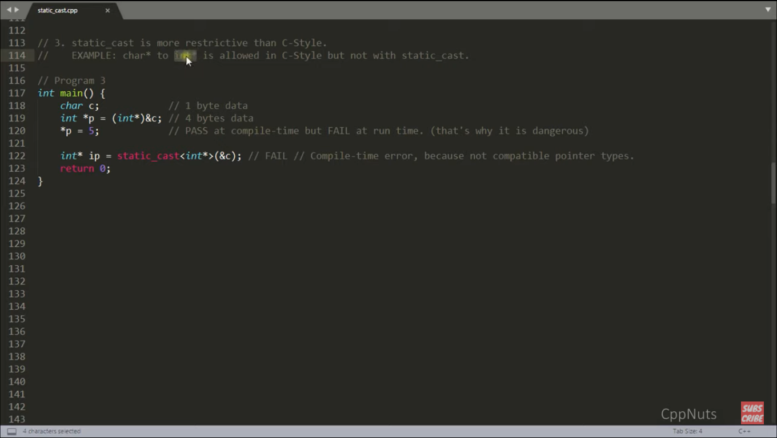

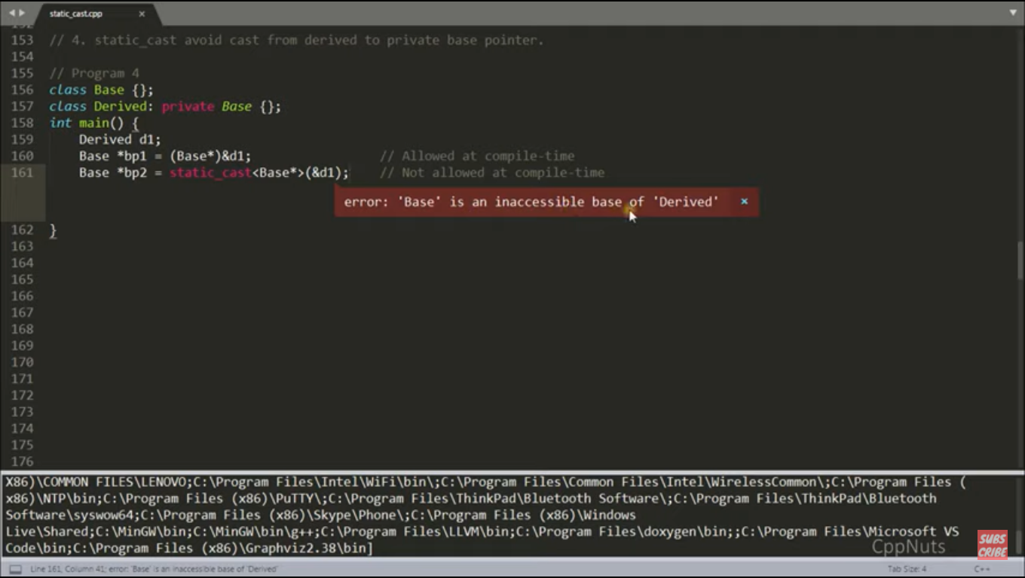

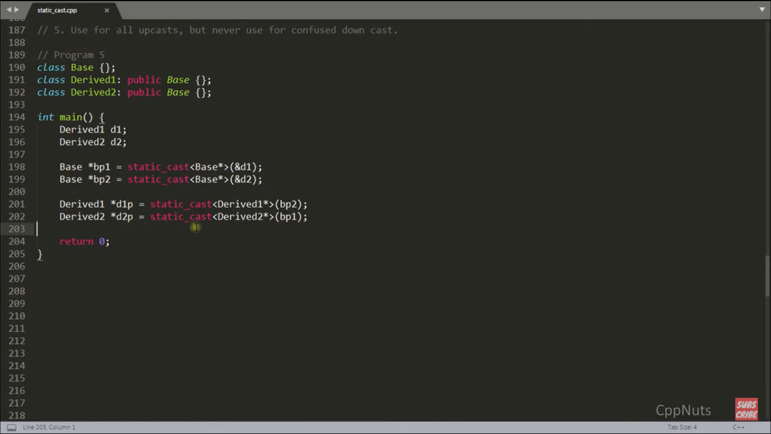

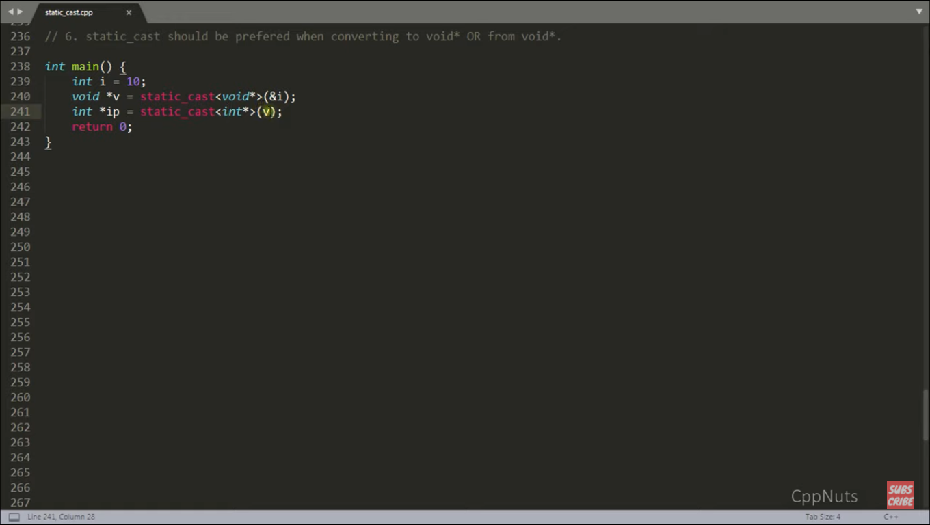

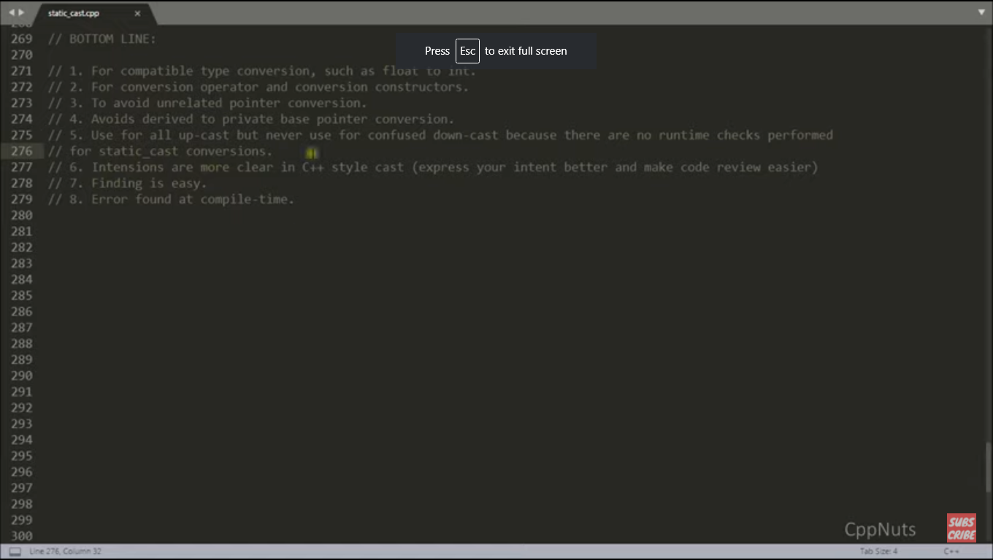

Qn : What is const_cast in C++ ?

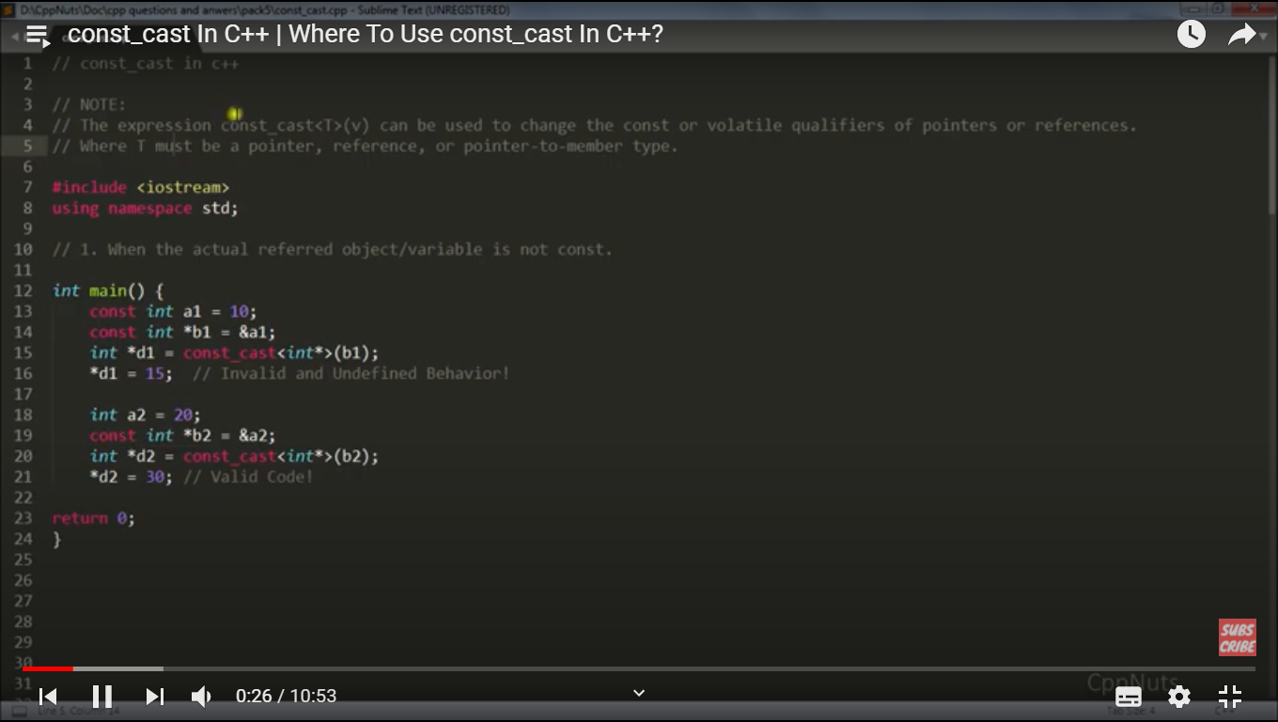

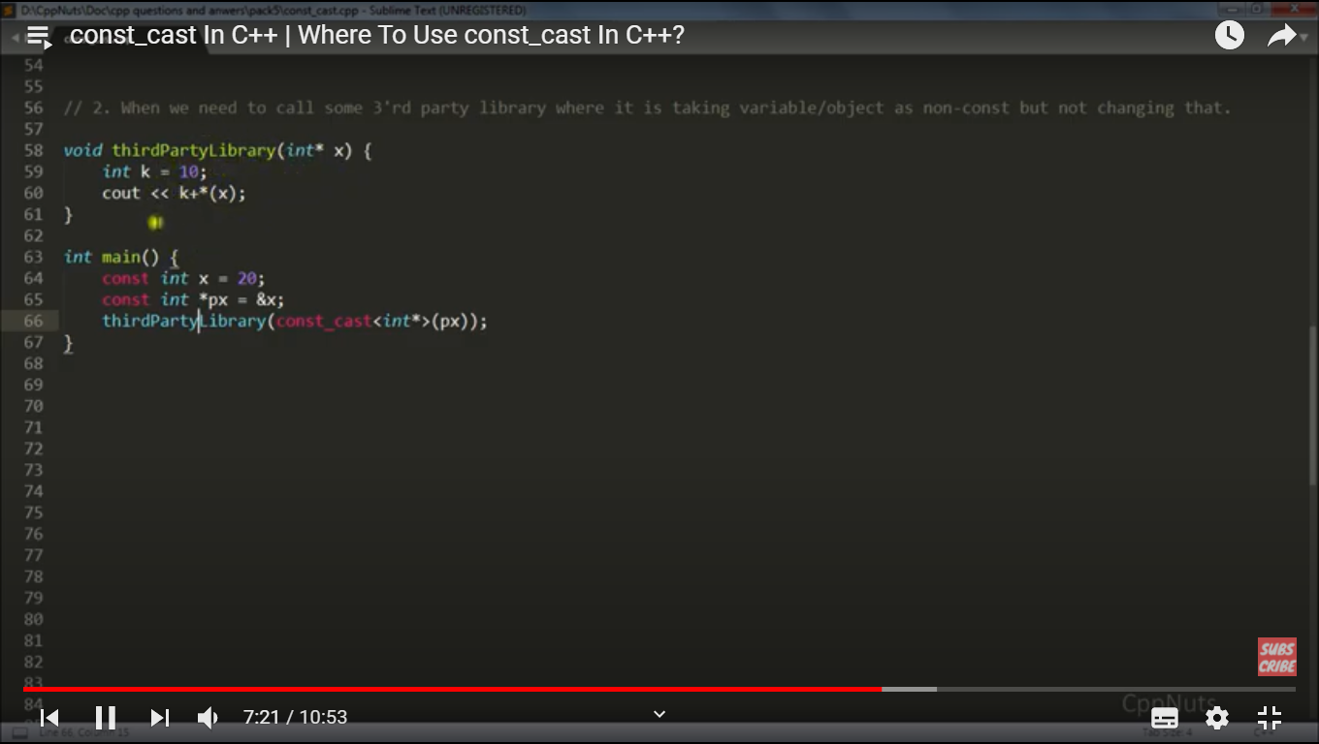

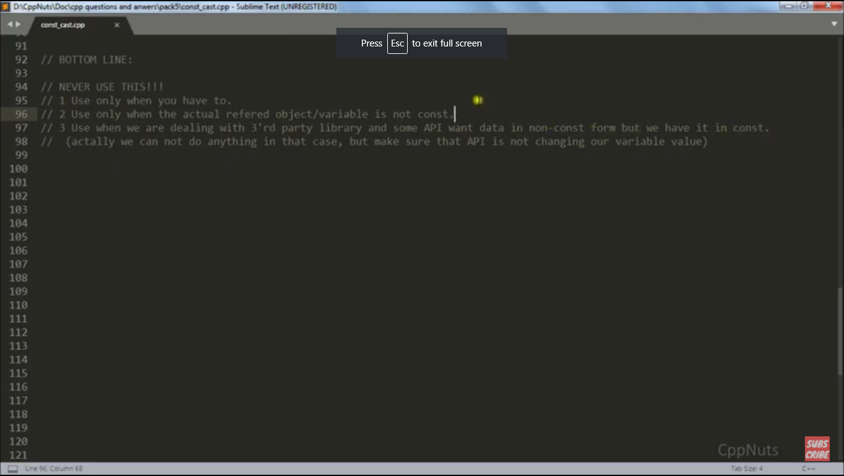

Qn : What is dynamic_cast in C++ ?

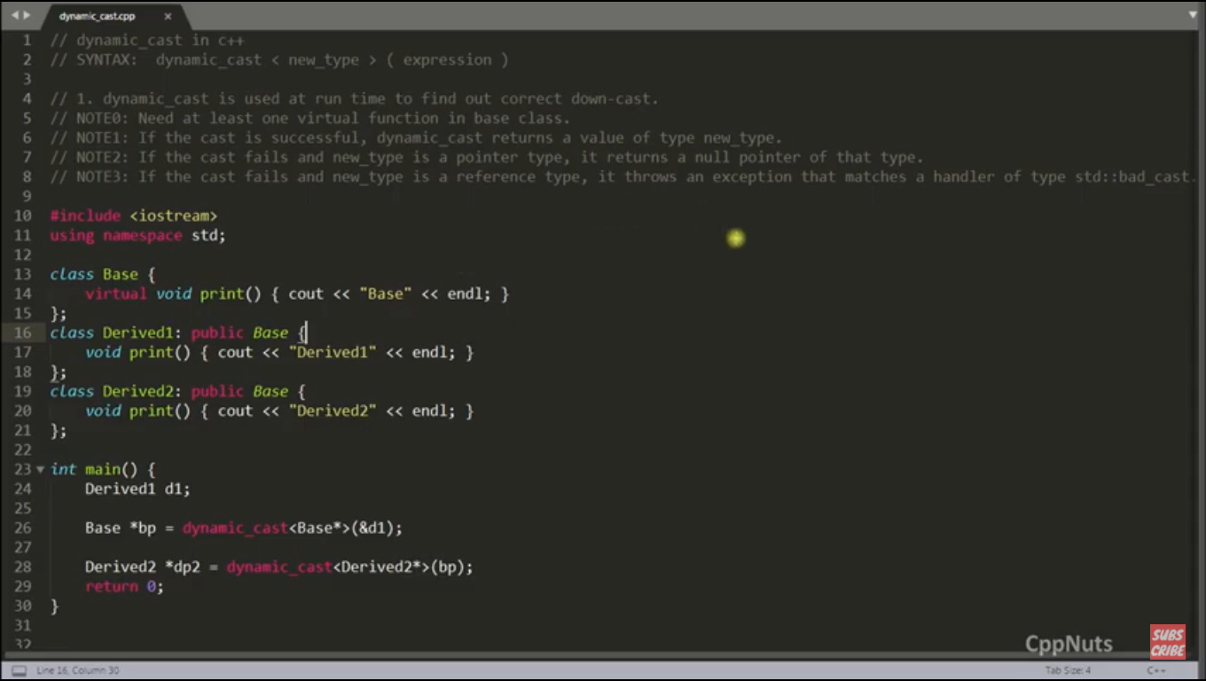

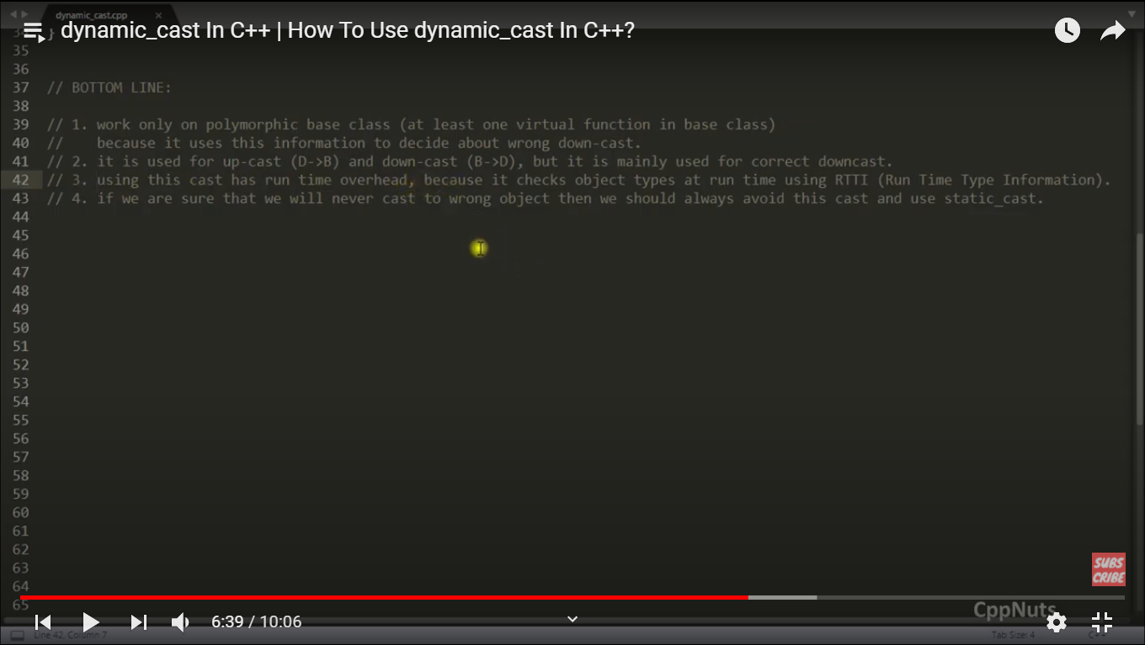

Qn : What is reinterpret_cast in C++ ?

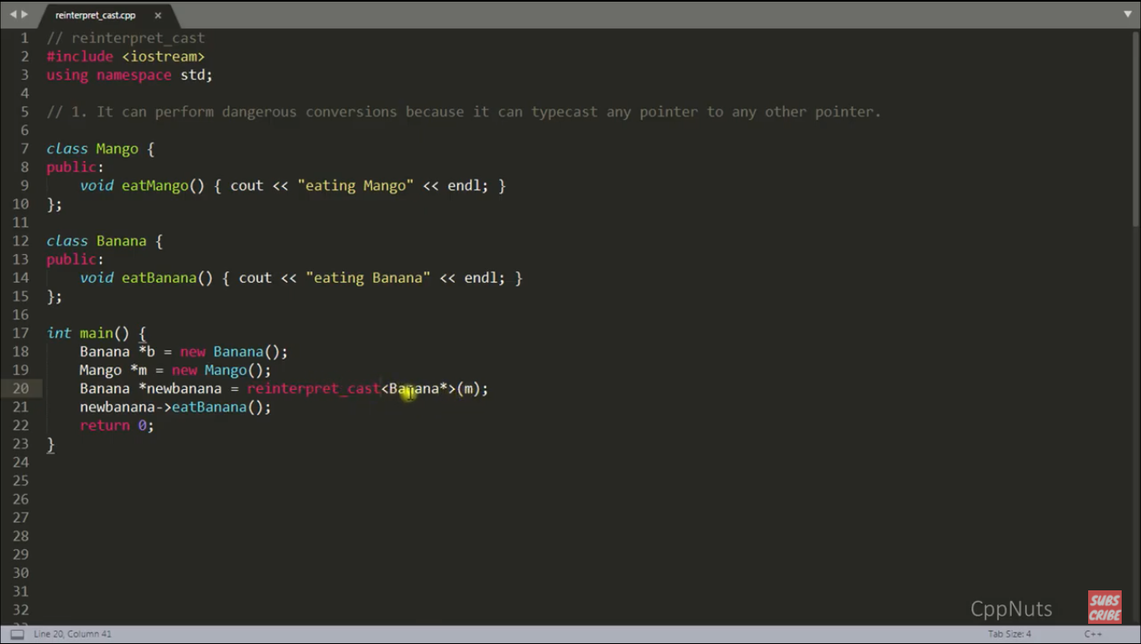

Qn: What is structural padding and packing ?

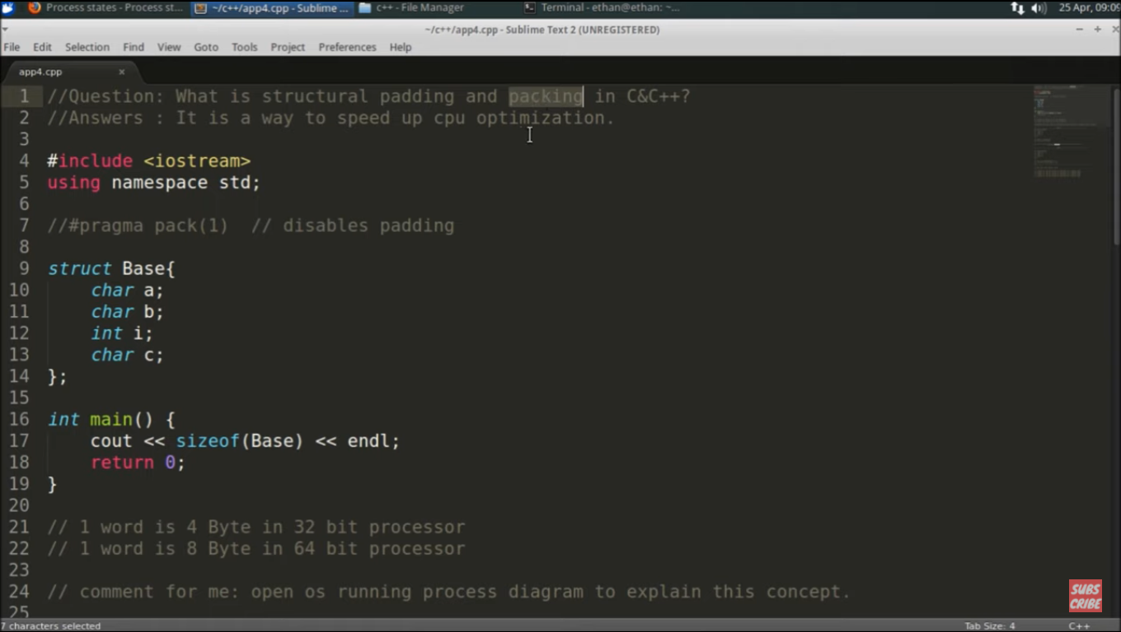

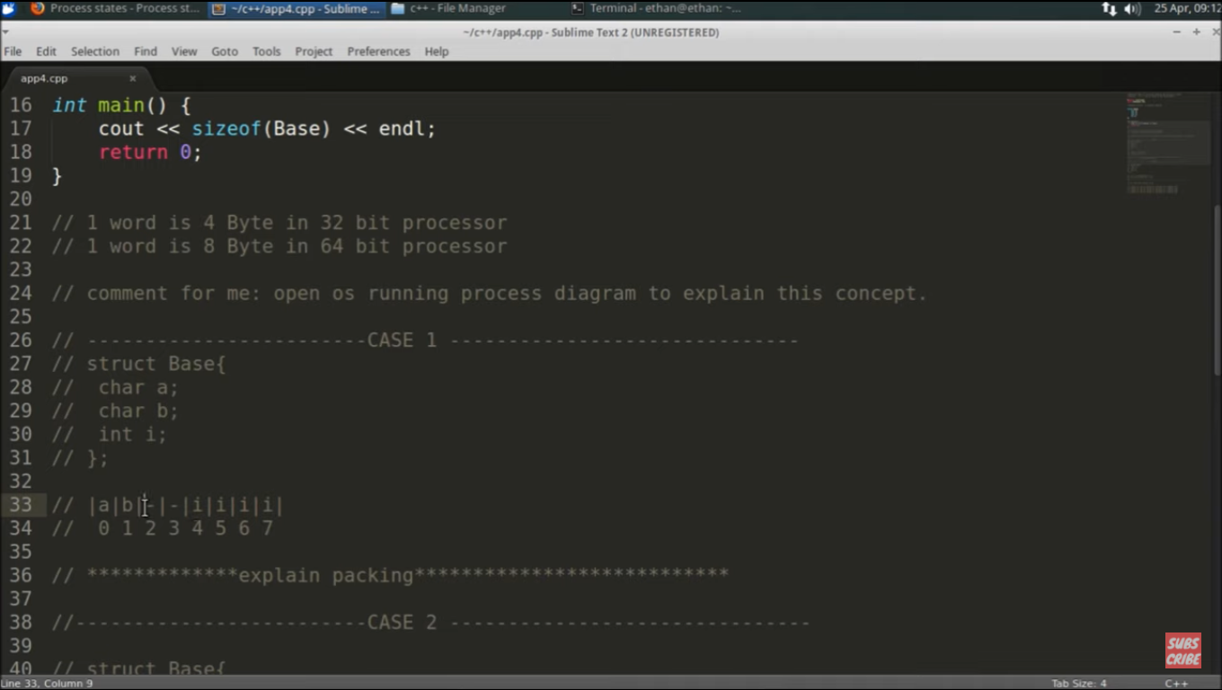

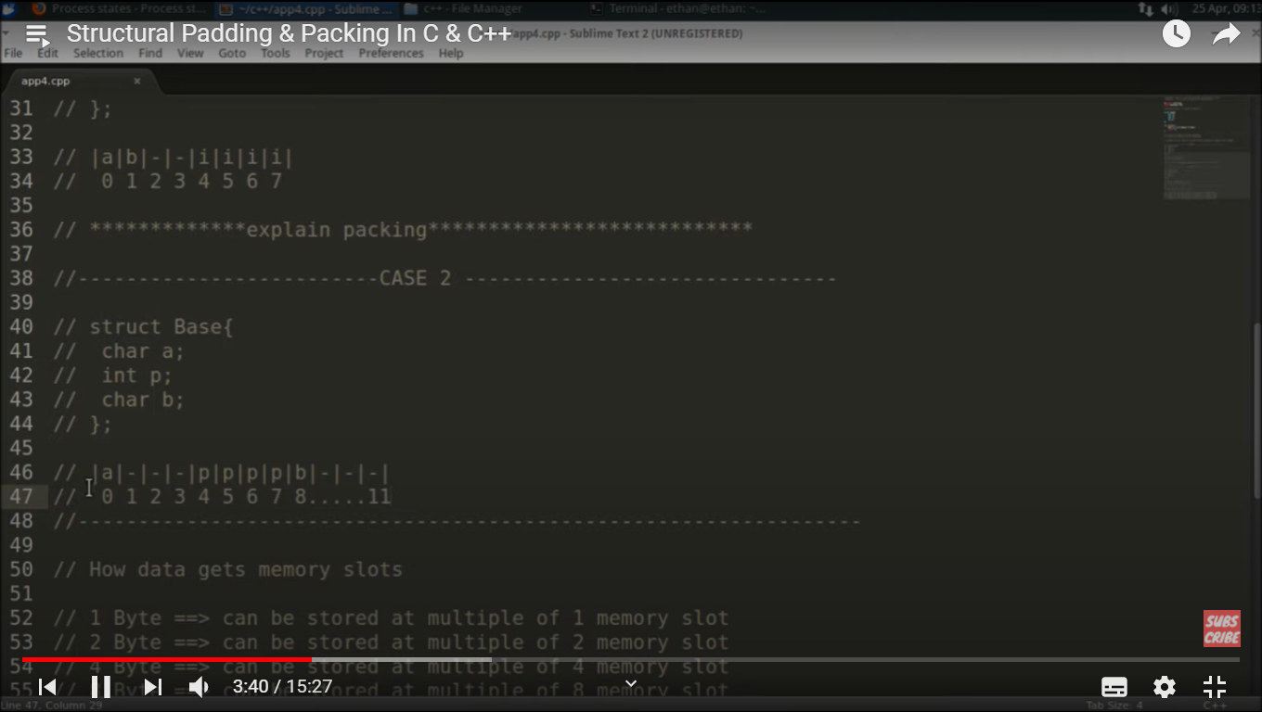

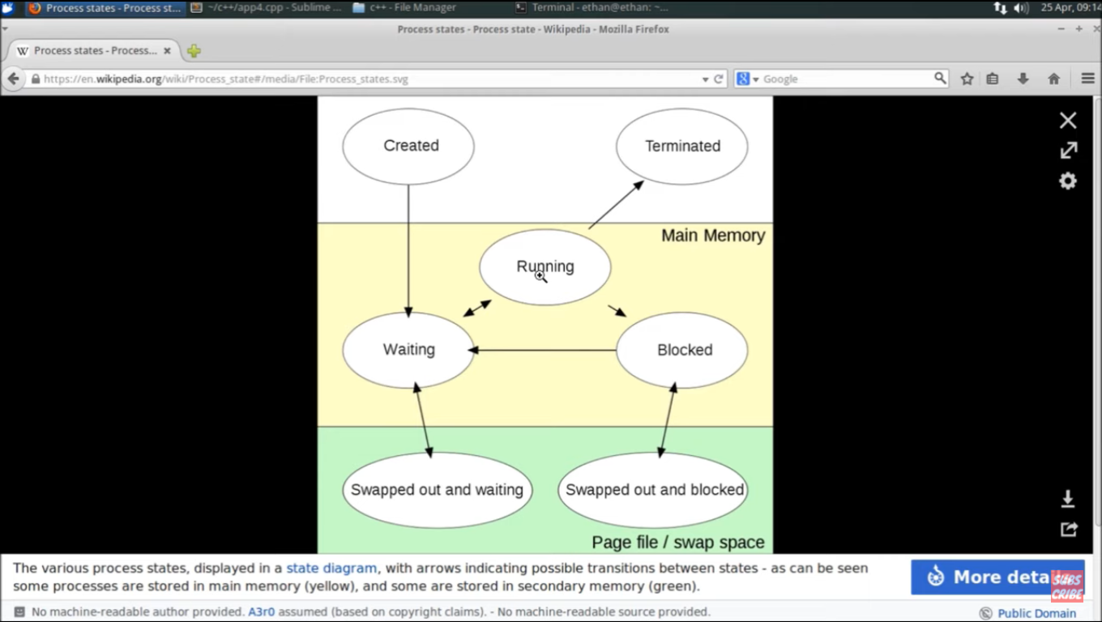

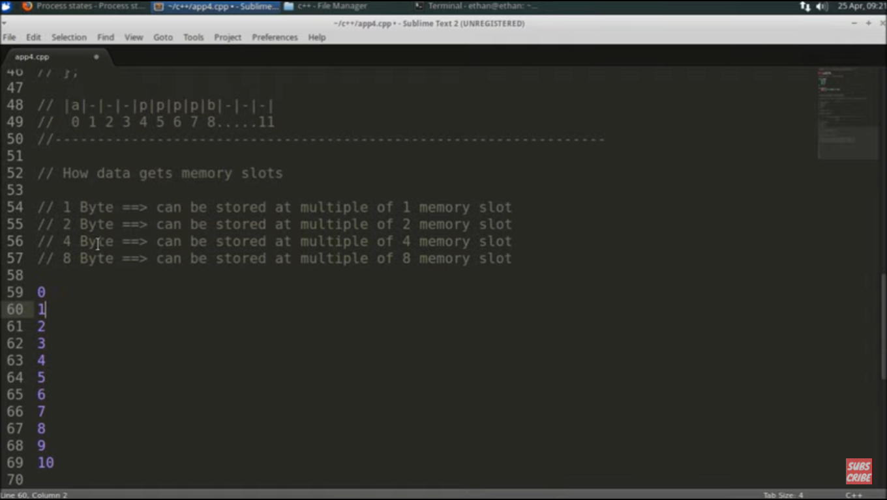

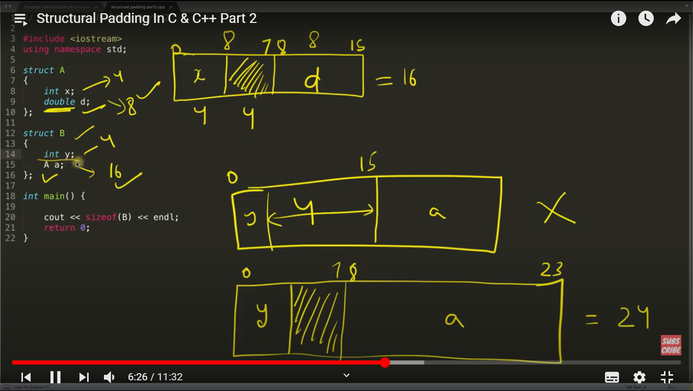

Qn : How to call some function before main() ?

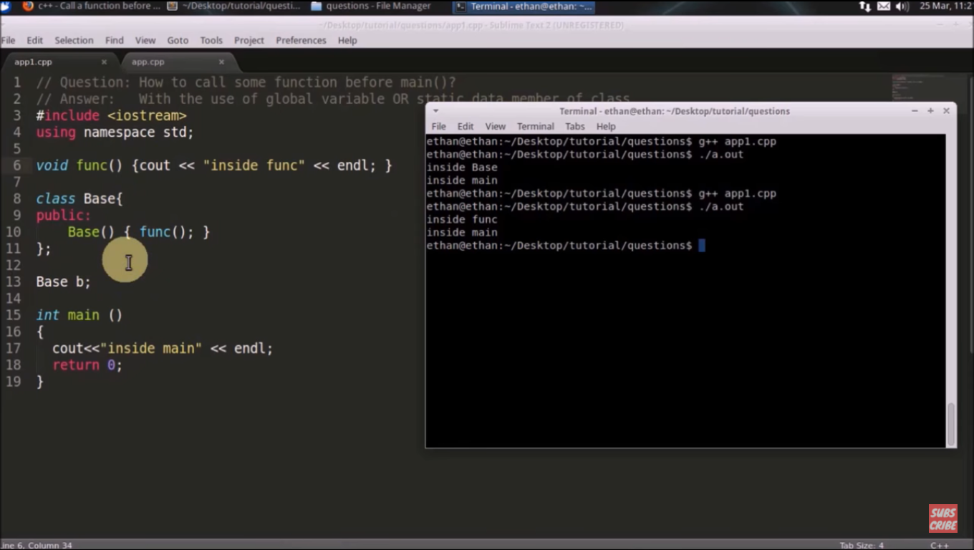

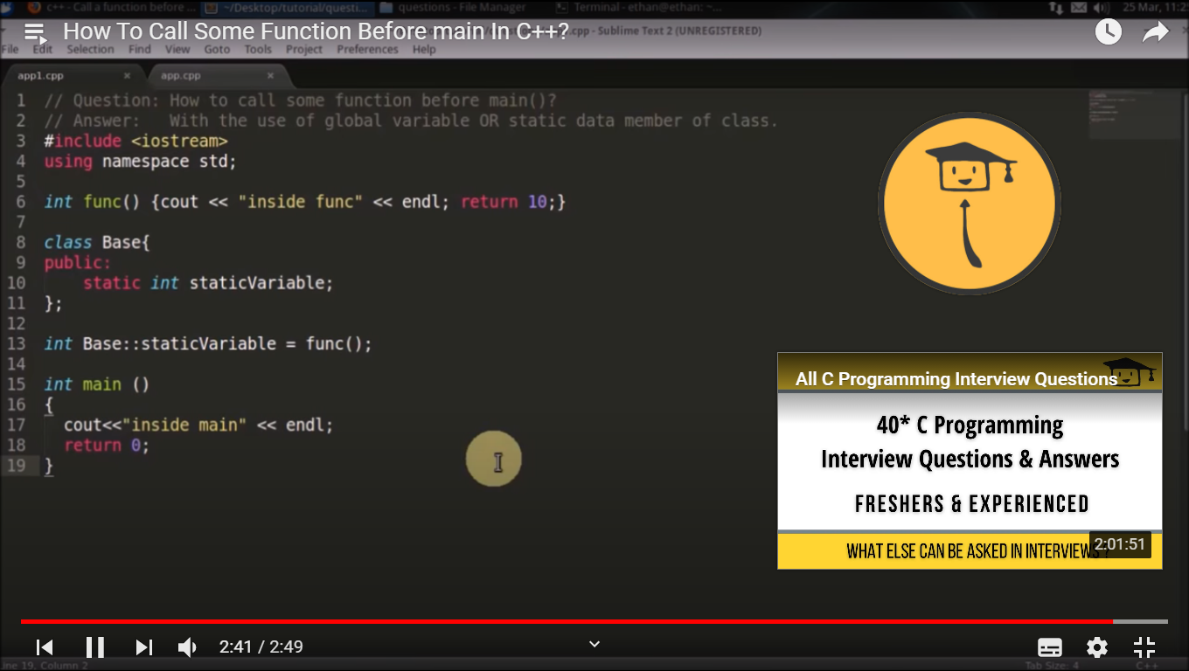

Qn : What is explicit constructor in C++ ?

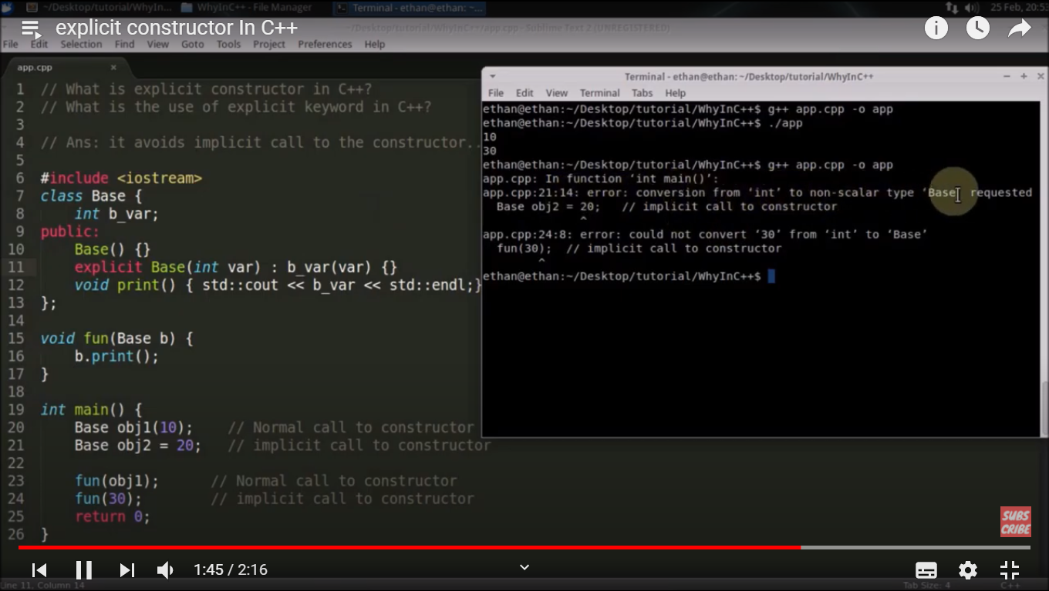

Qn : What is placement new in C++ ?

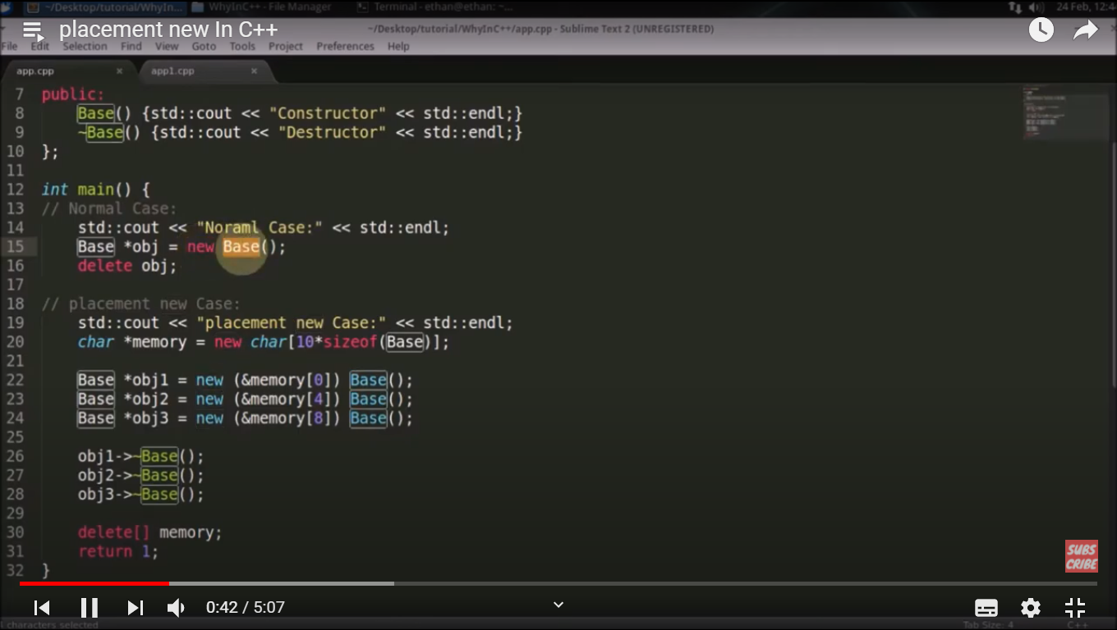

Qn : What is constructor delegation in C++ ?

It is used to avoid initialization part again and again.

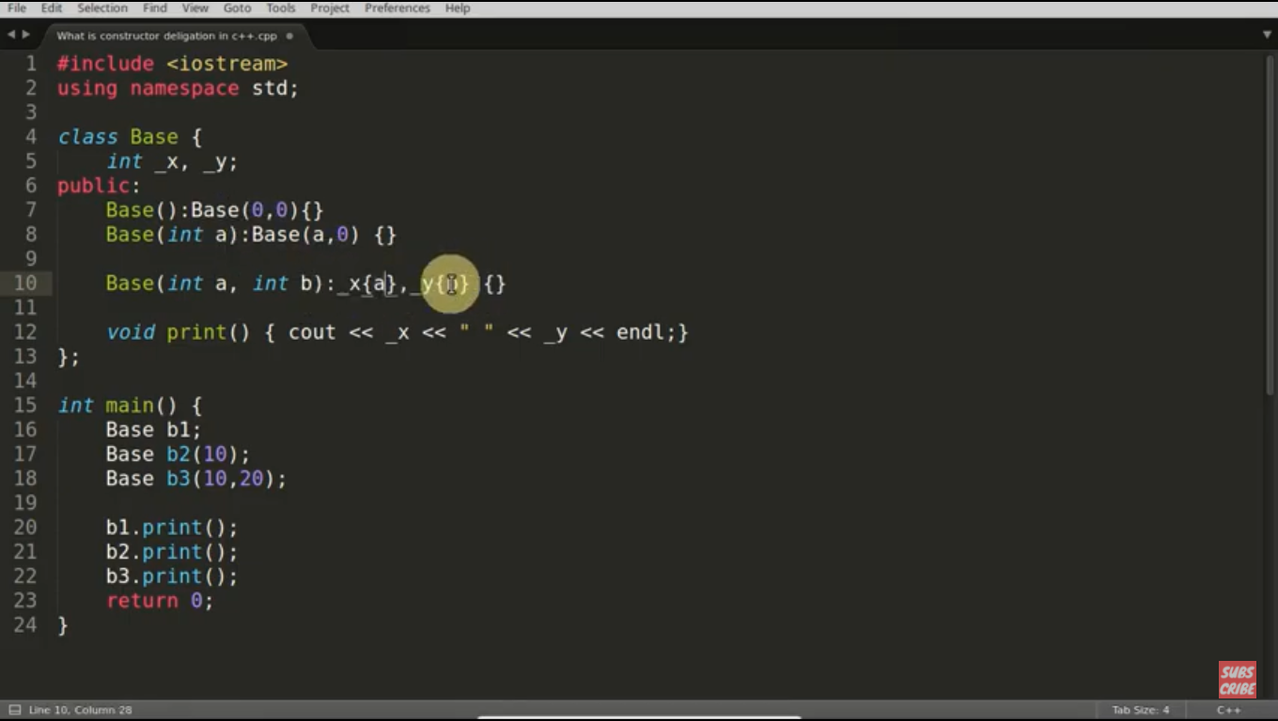

Qn : What is functor in C++ ?

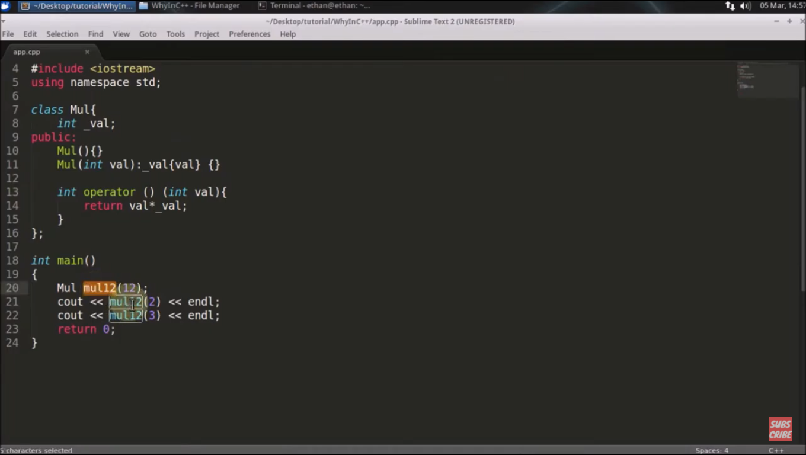

Qn : When use extern “C” in C++ ?

When C library compiled by c compiler and needs to be used in C++ code. It craetes problem during linking.

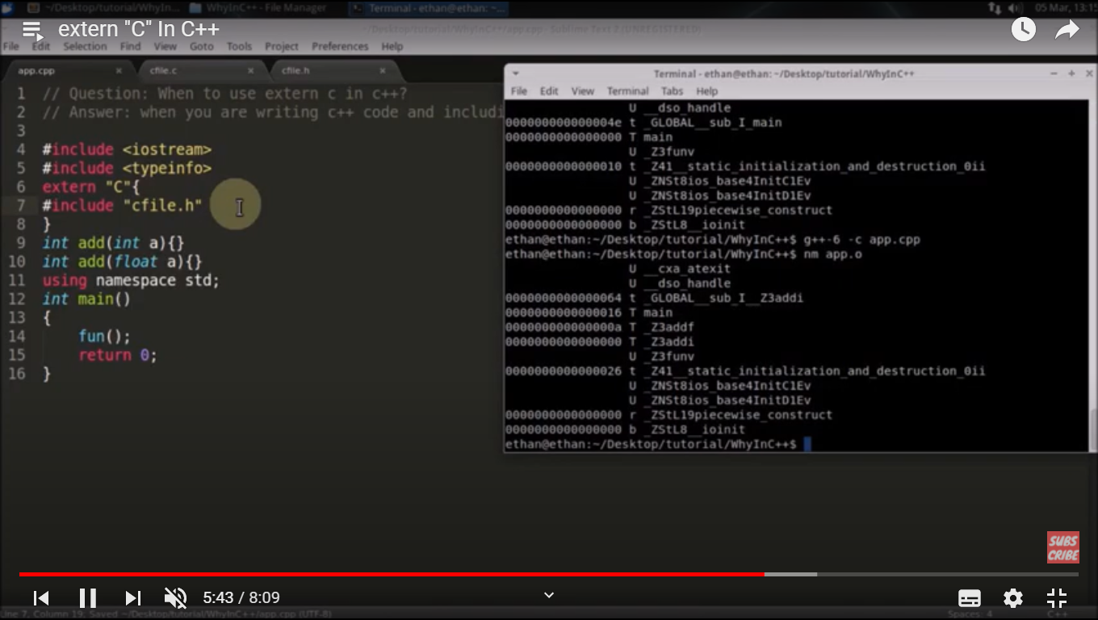

Qn : Why we need virtual destructor in C++ ?

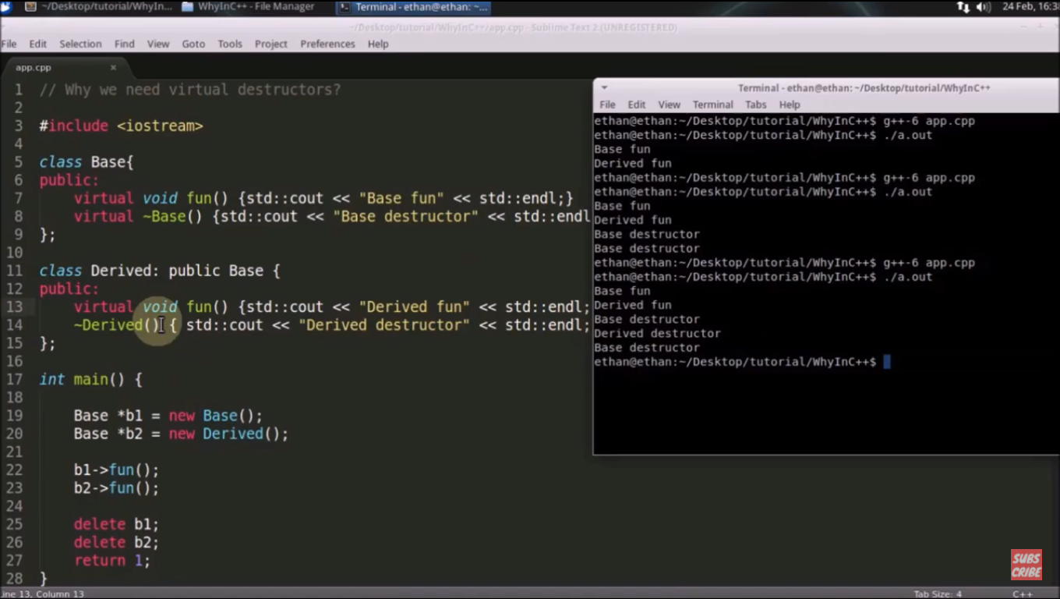

Qn : What printf() and scanf() returns ?

Printf() returns number of character printed on console successfully and scanf() returns number of character read from console successfully.

Qn: Why copy constructor takes argument as reference ?

If won’t pass by reference then constructor will be called recursively infinetly. Think of it.

We put const because we are creating a new object with help of an existing object and there shouldn’t be any intent to change the existing object.

Qn : How to assign object to primitive data type ?

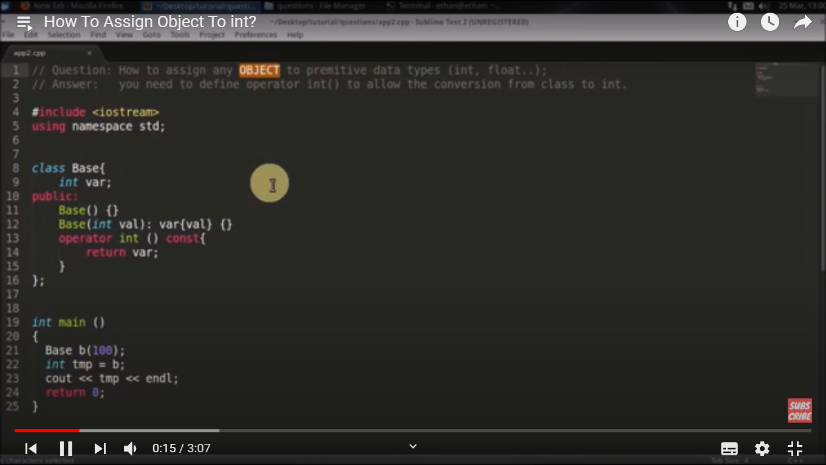

Qn : What is object slicing in C++ ?

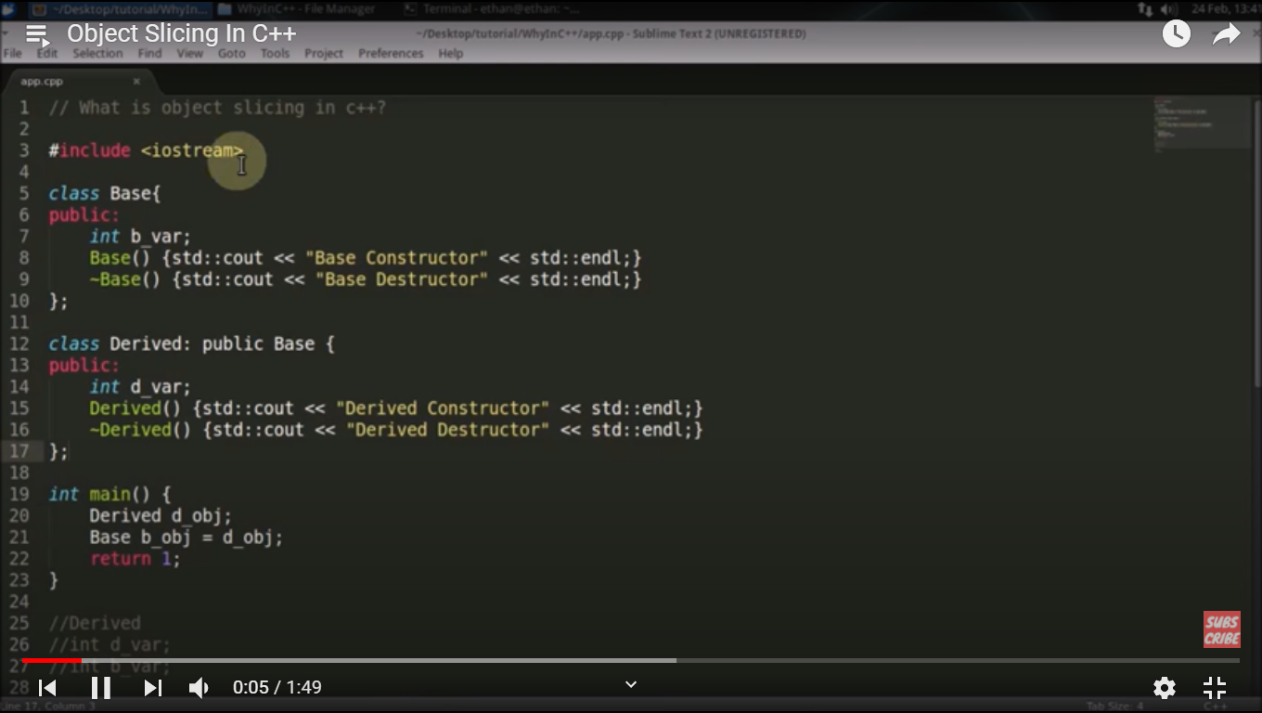

Qn : What is auto keyword in C++ ?

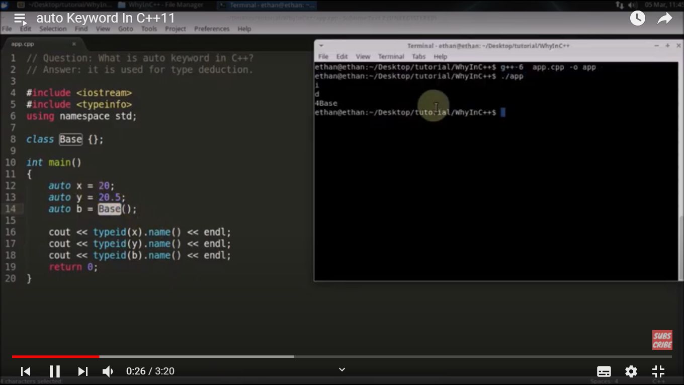

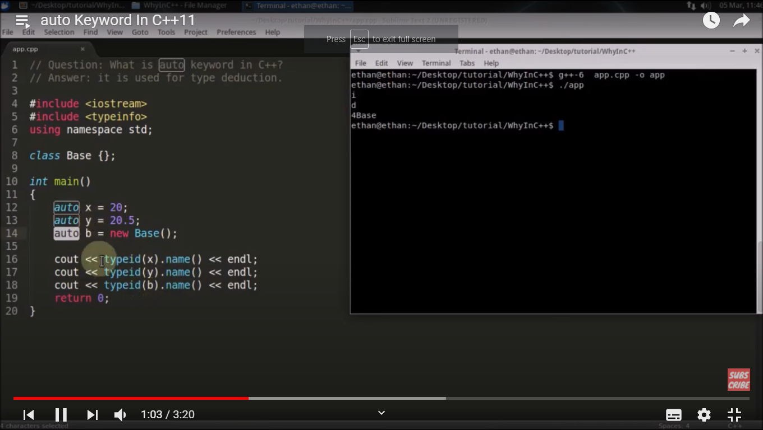

Qn: Can we call constructor and destructor explicitly ?

Yes we can call.

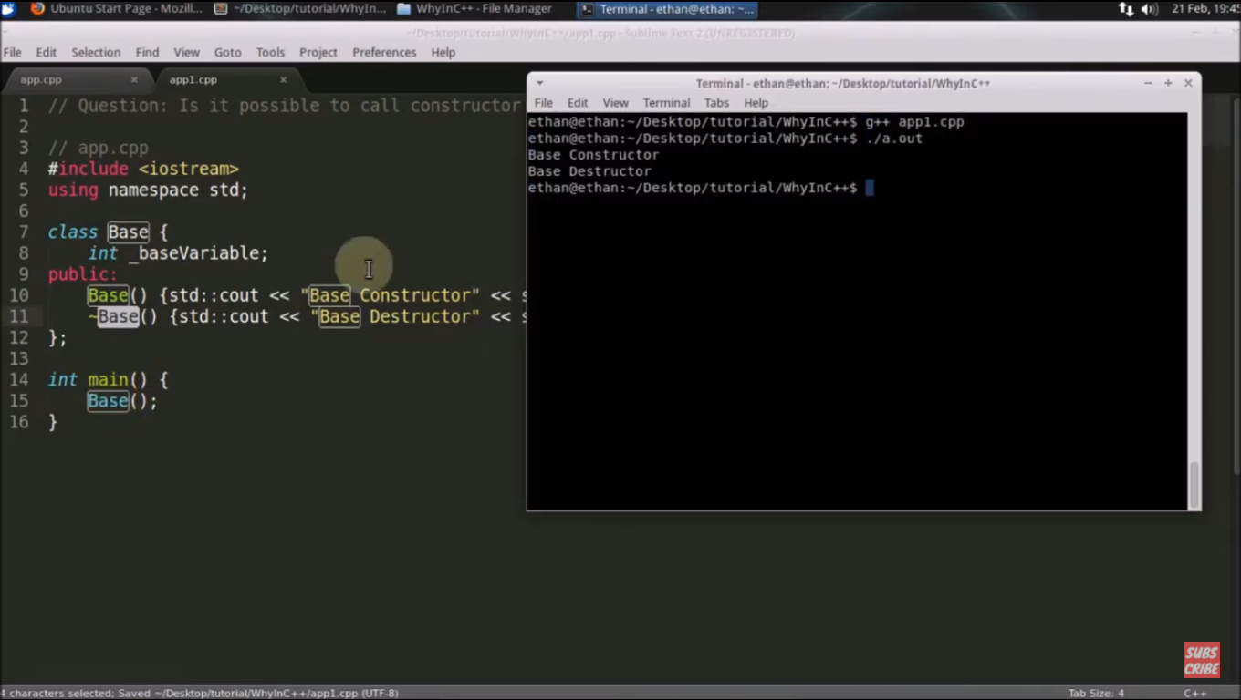

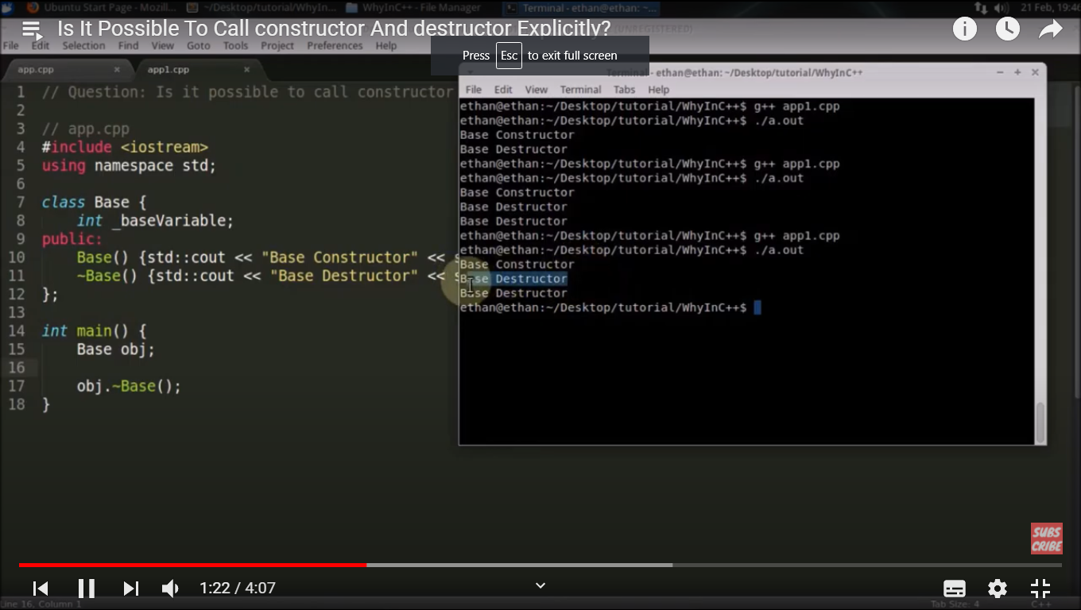

Note:

Class A {

};

A().~A(); // it will call destructor one time.

A obj;

Obj.~A()

// Here two times destructor is called because one is called explicitly and other is called by C++, there is guarantee from C++ as once you create an object. It will get deleted.

Qn : Why we must return reference in copy assignment operator?

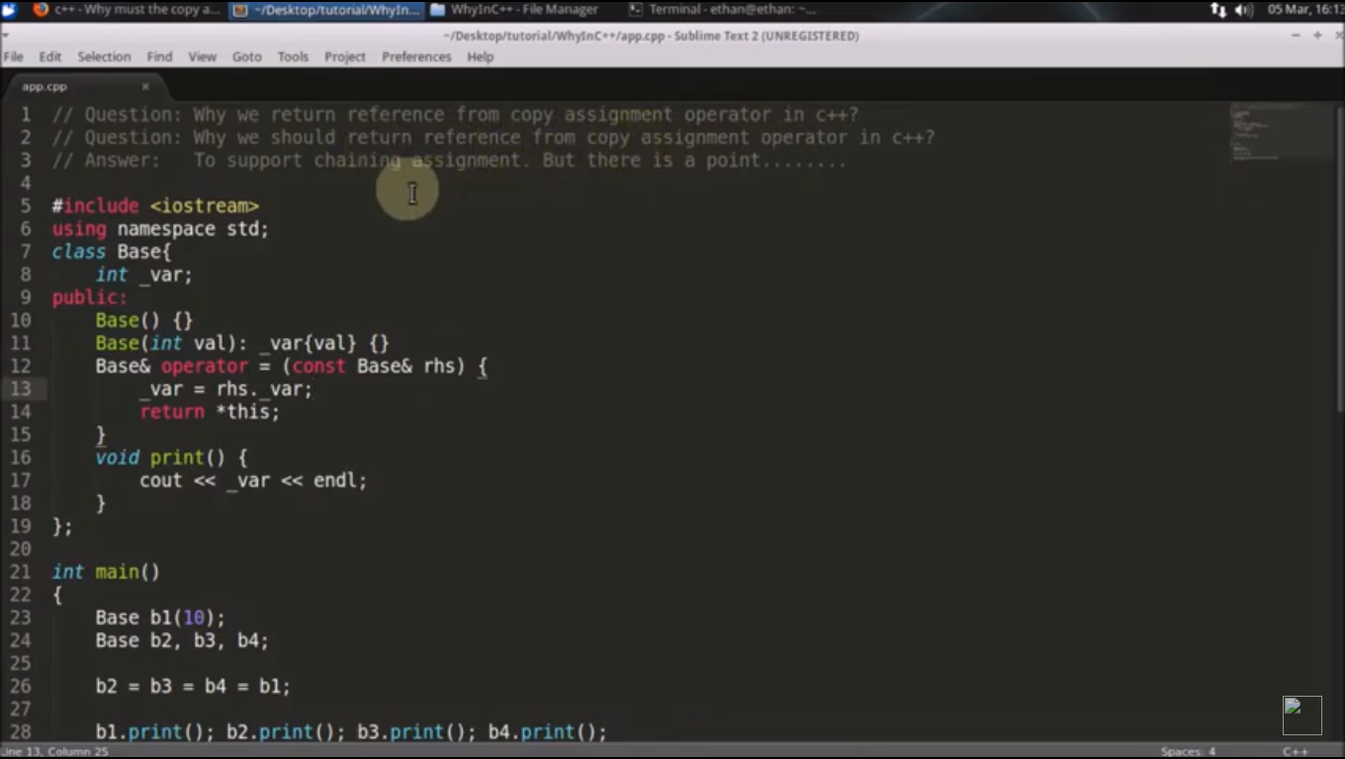

Qn : Why template function only defined inside header files ?

The below thing will not work because while compiling foo.h will have only declaration which is not type deduced. SO, it will create compiler error.

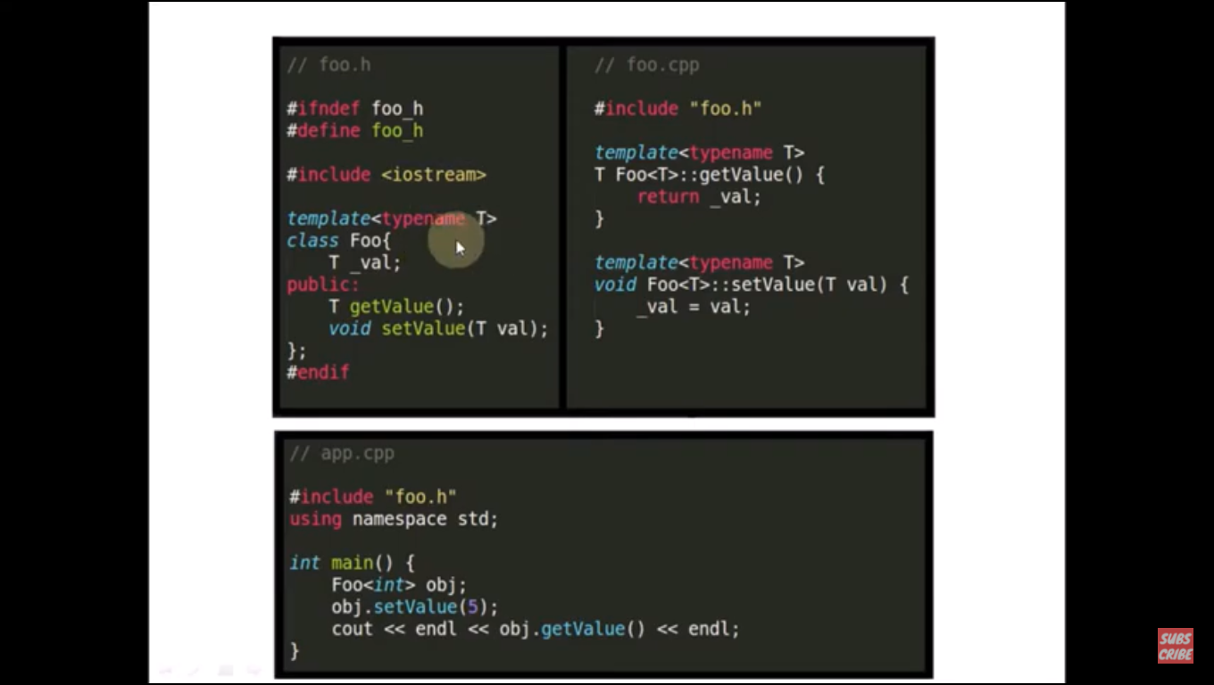

Then how to remove compiler error by keeping template function definition in different .cpp file.

We can include .cpp file in header file after declaration as mentioned in below pic. It will start working.

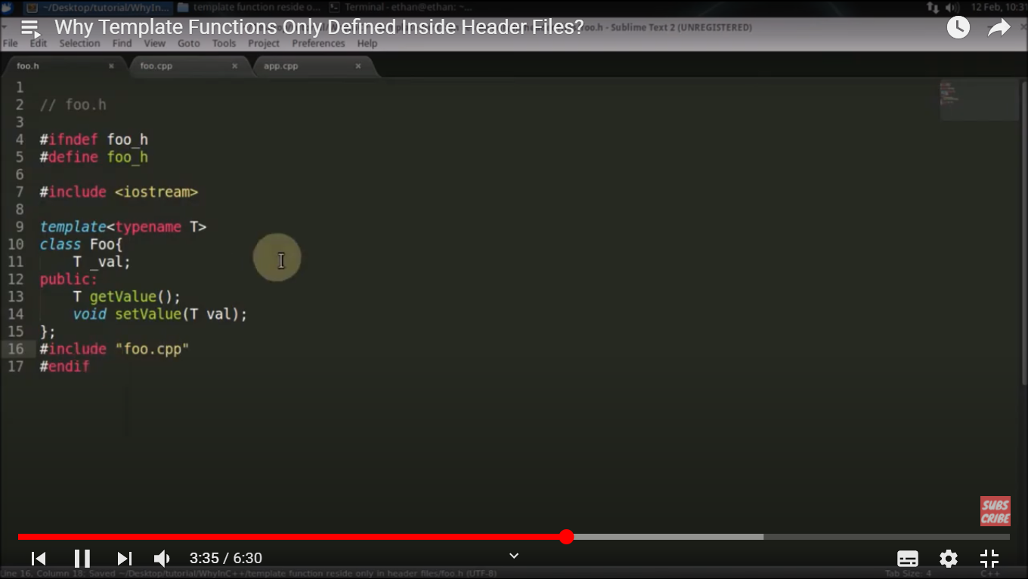

Second solution is instantiate function definition with some data type in .cpp file then also it will work.

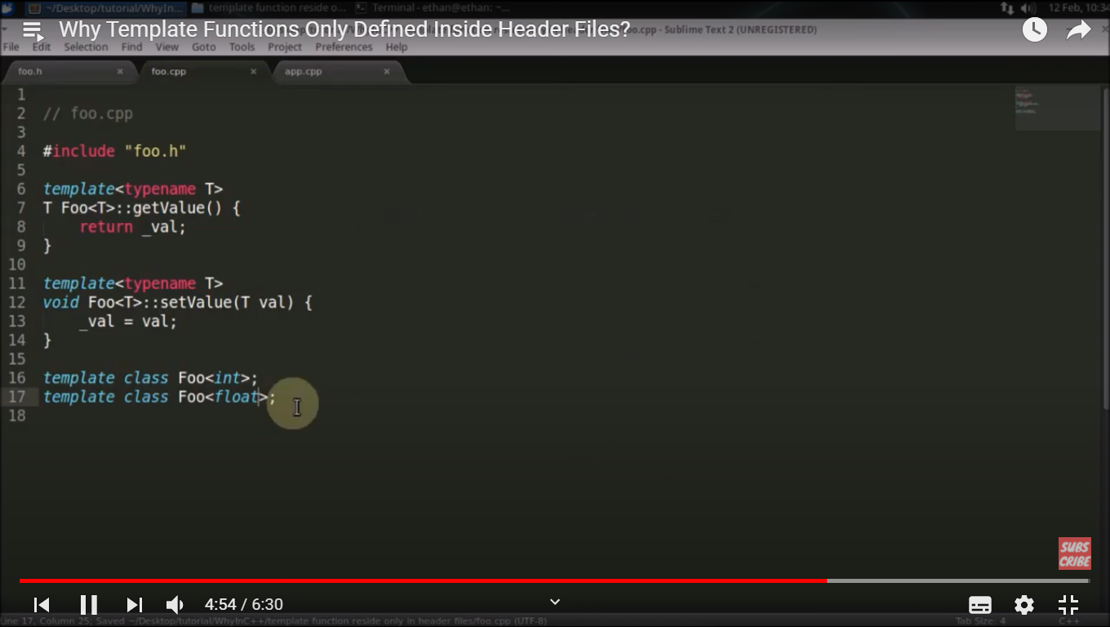

Qn: What is decltype in C++ and what’s the use?

Check the output below :

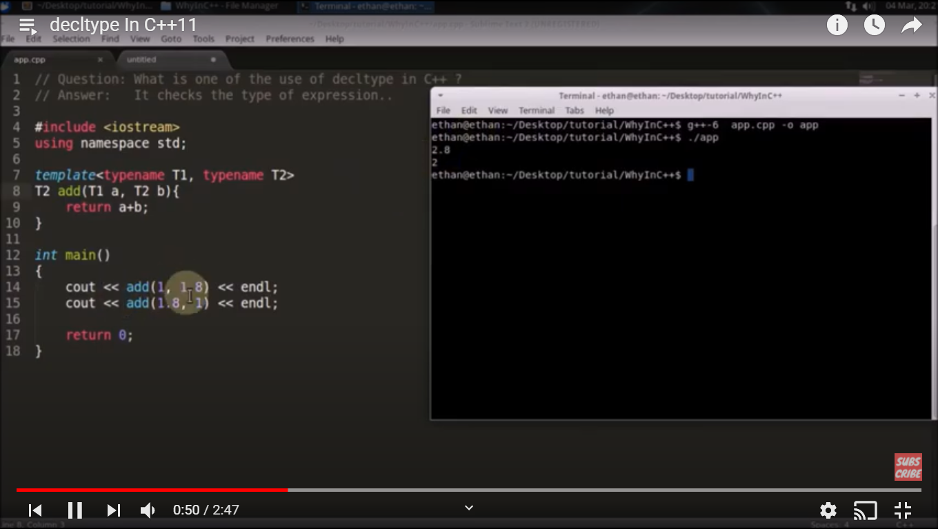

Solution is decltype:

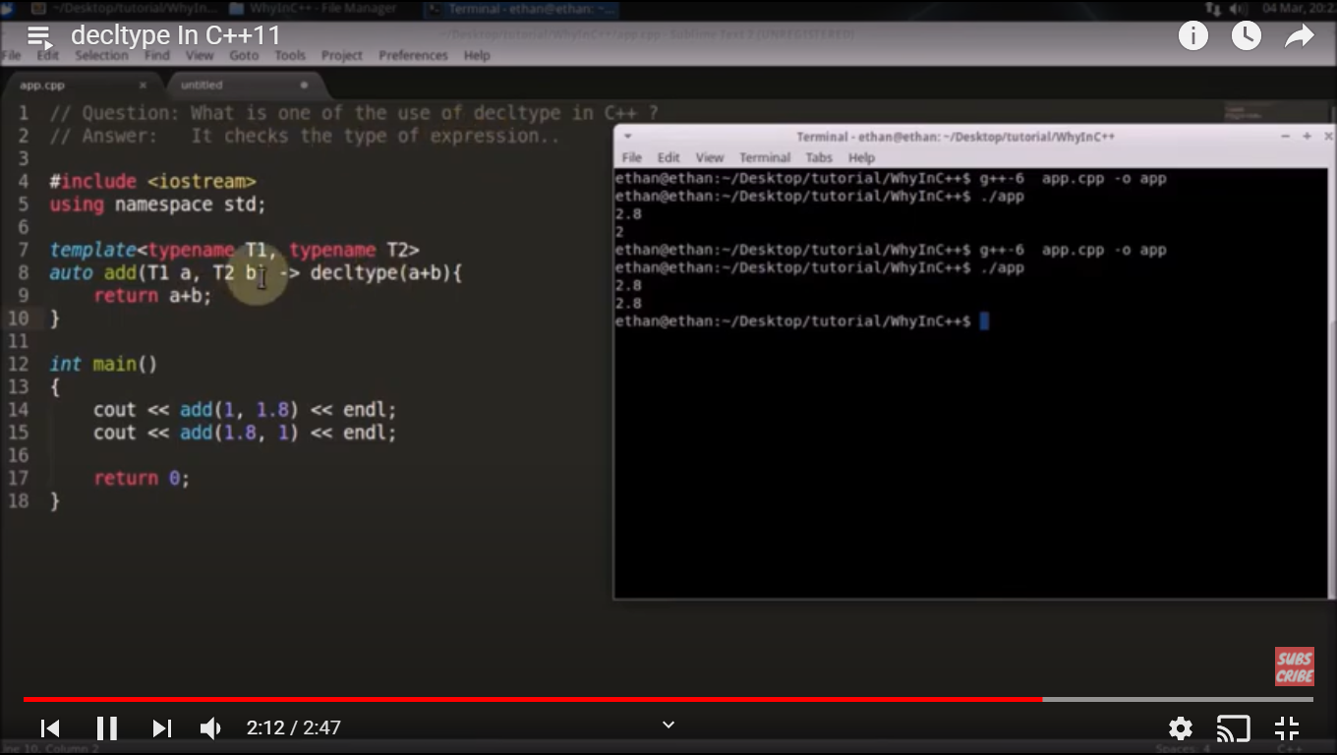

Qn: What is override keyword in C++ ?

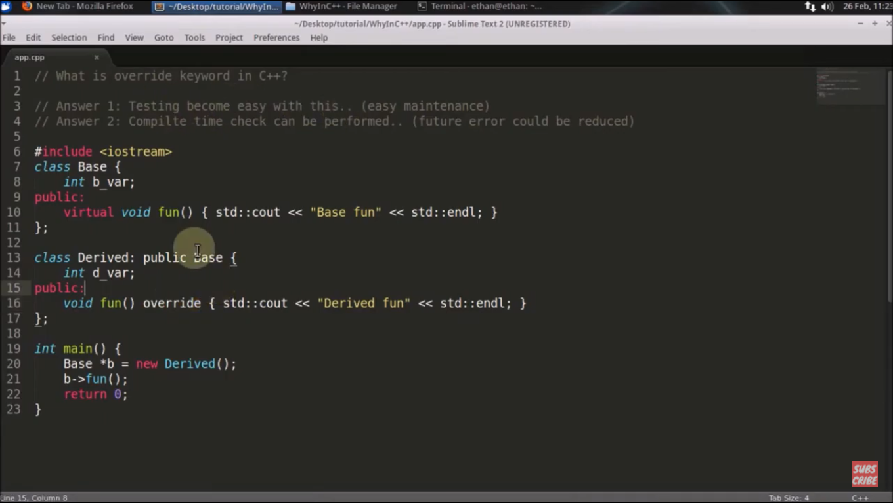

Qn : What is name mangling in C++?

To create only .o file from .cpp file:

g++ -c test.cpp -> it will generate test.o file.

Now, test.o is binary file so how can be check what test.o consists:

nm test.o // It will print the content of test.o, we can see the function names generated by compiler

// It shows symbol table generated by compiler

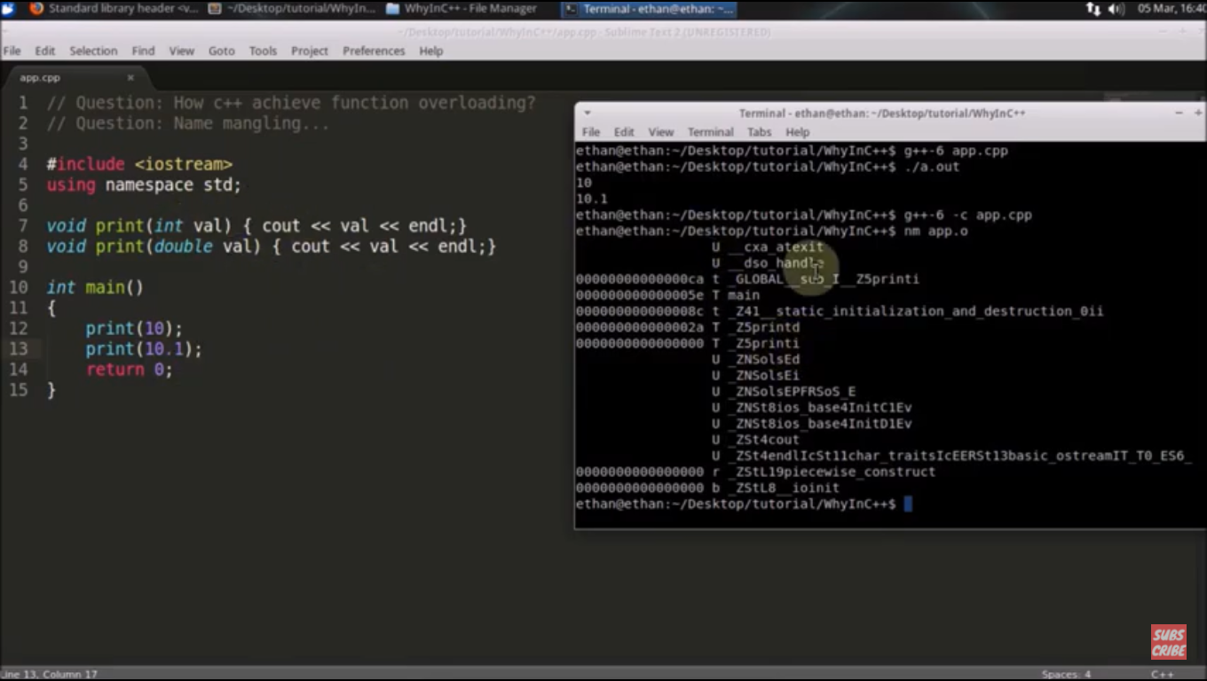

So, different name created by overloaded functions in c++ by compiler in symbol table is called name mangling.

Qn: What is the difference between range based for loop and for_each loop ? [These two are introduced in C++11 and further ]

For_each has control on the range but range based for loop doesn’t have control on range in the loop, it iterates from begin to end.

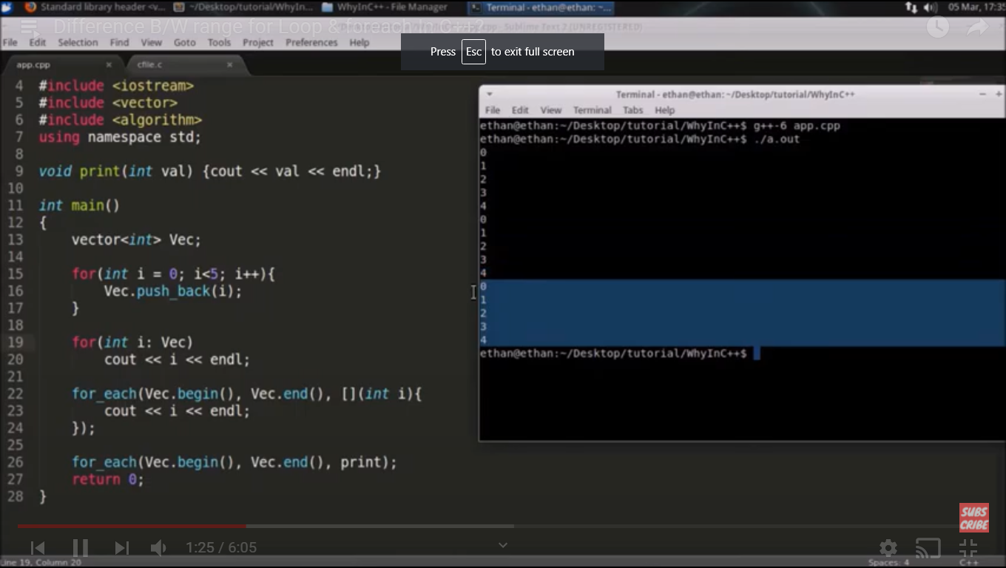

Another difference is range based for loop works on array as well but for_each doesn’t work for array, it requires begin oterator and end iterator.

Qn: What is the drawback of using vector in C++ ?

